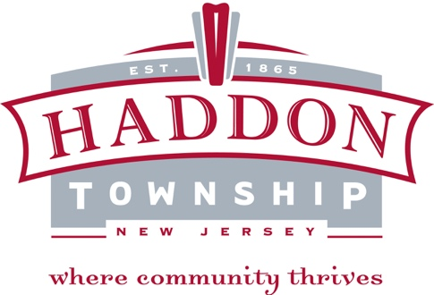

Rent Control Board
The Township of Haddon Rent Control Board is the municipal agency primarily responsible for administering Chapter 189 of the Township Code. Chapter 189 sets forth the procedures and standards for rent increase and decrease applications relating to any properties coming under the scope of Chapter 189. R
Rent Control Board Members
Larry Gasperone, Chairperson, Homeowner
Kimberlie Wagner, Vice Chair, Homeowner
Kimberly Monzo, Homeowner
Candice S. Winters, Homeowner, Alternate #1
Jamie Hurley- Homeowner Alternate #2
David Murdock, Tenant Rep
Virginia J. Ferry, Tenant Rep. Alt
Nicholas Kikis - Landlord Rep.
Vacant - Landlord Alternate
The Rent Control Board meetings are held the 4th Thursday of every other month: January, March, May, July, September and November at 6:00 pm in the courtroom on the 2nd floor of the Municipal Building. The office of Rent Control assists landlords and tenants in understating the impact the Municipal Rent Control Ordinance for the Township of Haddon, may have on their properties and apartments. Technical assistance is provided on a wide variety of rental issues which cover such matters as: which apartments are subject to local rent control laws; what is the legal base rent; what rent increases the law permits; tax surcharges; water/sewer surcharges; major new improvement surcharges; hardship increases; and annual registration requirements.

