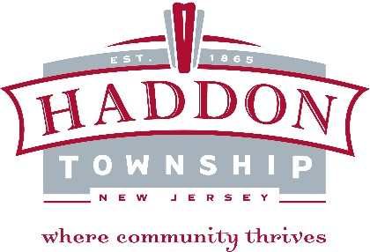

Haddon Township Environmental Commission
- Marjorie Liebe, Chairman
- Marlene Finizio
- Christopher Martin
- Marguerite Downham
- Amanda Vile-Sickler, member
- Erin MacMinn, member
- Christopher Squazzo, member
- Cara Weismann, member
- Kevin Randall, Alt 1
- Vacancy, Alt 2
The Haddon Township Environmental Commission was created in June 2002 to advise the township’s government on environmental matters. Its responsibilities include compiling an index of open space, and making recommendations for its planning and use and acquiring property in the name of the municipality. The Commission develops and maintains an Environmental Resource Inventory, and studies and makes recommendations on open space preservation, water resources management, air pollution control, solid waste management, noise control, soil and landscape protection, environmental appearance, marine resources and protection of flora and fauna. It also oversees the management of the Saddler's Woods Conservation Area. The Mayor appoints its seven members plus two alternates. One member of the Environmental Commission also serves on the Planning/Zoning Board, and the Commission advises the Planning/Zoning Board on development proposals that may have environmental impacts. The Environmental Commission also works on investigating environmental problems and offering solutions, and researching and proposing ordinances. In addition to these formal duties, the Commission often provides education and information to the public on environmental protection, and works with other local, regional, state, and federal agencies in supporting environmental programs. The Environmental Commission helps maintain a dialog between citizens and their elected officials, and serves as an advocate within the municipality with a formally-outlined set of responsibilities for issues that impact the town’s quality of life. The Environmental Commission’s regular meetings are held on the third Wednesday of every month at 7:00 PM, at the Haddon Township Environmental and Historical Education Center at 143 East Ormond Avenue. The public is always welcome and encouraged to attend. More information about the Environmental Commission can be found in Chapter 27 of the Code of the Township of Haddon online or through the Municipal Clerk’s Office. Additionally, the Environmental can be contacted at EnviroComm@haddontwp.com.

