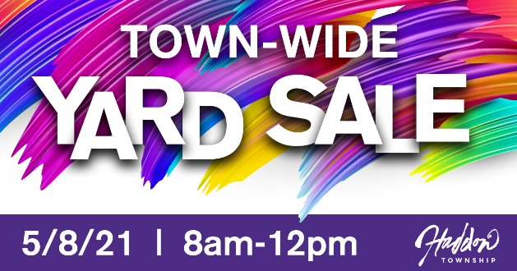

404 Albany Ave.
201 Ardmore Ave.
607 Avondale Ave.
912 Belmont Ave.
410 Bradford Ave.
425 Bradford Ave.
408 Briarwood Ave.
199 Burrwood Ave.
249 Burrwood Ave.
109 Cooper St.
269 Crystal Terrace
277 Crystal Terrace
23 E. Crystal Lake Ave.
201 Cooper St.
2 E. Clinton Ave.
46 E. Kraft Ave.
48 E. Kraft Ave.
129 E. Park Ave.
207 Fern Ave.
217 Fern Ave.
508 Fern Ave.
706 Graisbury Ave.
107 Geneva Ave.
15 Hampton Road
204 Harding Ave.
213 Harding Ave.
308 Ivywood Ave.
311 Ivywood Ave.
316 Jess Ave.
403 Locust Ave.
60 Melrose Ave.
214 Morgan Ave.
217 Morgan Ave.
221 Morgan Ave.
271 New Jersey Ave.
103 Norwood Ave.
215 Norwood Ave.
14 Oriental Ave.
1101 Oriental Ave.
106 S. Atlantic Ave.
18 Stratford Ave.
41 Stratford Ave.
49 Stratford Ave.
57 Stratford Ave.
401 Strawbridge Ave.
51 Sunset Lane
601 Tatem Ave.
87 Utica Ave.
119 Utica Ave.
103 Virginia Ave.
117 Virginia Ave.
218 Virginia Ave.
233 Virginia Ave.
107 W. Albertson Ave.
205 W. Crystal Lake Ave.
145 W. Cuthbert Blvd.
210 W. Cuthbert Blvd.
901 W. Mt. Vernon Ave.
1001 W. Mt. Vernon Ave.
906 W. Redman Ave.
910 W. Redman Ave.
14 W. Walnut Ave.
402 Westmont Ave.

