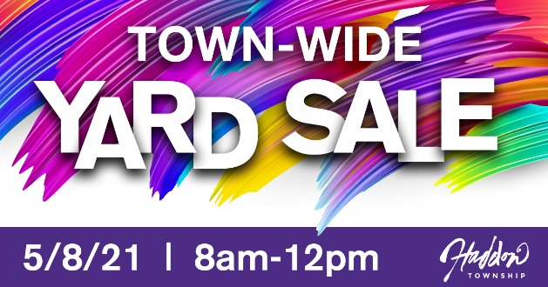

404 Albany Ave.
201 Ardmore Ave.
607 Avondale Ave.
912 Belmont Ave.
269 Bewley Road
410 Bradford Ave.
425 Bradford Ave.
426 Bradford Ave.
408 Briarwood Ave.
199 Burrwood Ave.
249 Burrwood Ave.
109 Cooper St.
269 Crystal Terrace
277 Crystal Terrace
201 Cooper St.
2 E. Clinton Ave.
16 E. Clinton Ave.
23 E. Crystal Lake Ave.
101 E. Cuthbert Blvd.
46 E. Kraft Ave.
48 E. Kraft Ave.
213 Emerald Ave.
215 Emerald Ave.
129 E. Park Ave.
207 Fern Ave.
217 Fern Ave.
508 Fern Ave.
107 Geneva Ave.
513 Glendale Ave.
305 Glenwood Ave.
25 Golden Alley
401 Graisbury Ave.
706 Graisbury Ave.
15 Hampton Road
204 Harding Ave.
213 Harding Ave.
308 Ivywood Ave.
311 Ivywood Ave.
316 Jess Ave.
403 Locust Ave.
60 Melrose Ave.
206 Morgan Ave.
214 Morgan Ave.
217 Morgan Ave.
218 Morgan Ave.
221 Morgan Ave.
268 New Jersey Ave.
271 New Jersey Ave.
103 Norwood Ave.
215 Norwood Ave.
14 Oriental Ave.
27 Oriental Ave.
1101 Oriental Ave.
801 Saginaw Ave.
106 S. Atlantic Ave.
18 Stratford Ave.
41 Stratford Ave.
49 Stratford Ave.
57 Stratford Ave.
105 Strawbridge Ave.
249 Strawbridge Ave.
401 Strawbridge Ave.
51 Sunset Lane
601 Tatem Ave.
611 Tatem Ave.
87 Utica Ave.
119 Utica Ave.
103 Virginia Ave.
117 Virginia Ave.
218 Virginia Ave.
233 Virginia Ave.
107 W. Albertson Ave.
205 W. Crystal Lake Ave.
145 W. Cuthbert Blvd.
210 W. Cuthbert Blvd.
901 W. Mt. Vernon Ave.
1001 W. Mt. Vernon Ave.
906 W. Redman Ave.
910 W. Redman Ave.
109 W. Albertson Ave.
14 W. Walnut Ave.
402 Westmont Ave.

