Camden County Ballot Drop Box Locations

Audubon Municipal Building 606 West Nicholson Road
Chesilhurst Municipal Building 201 Grant Ave., Waterford Works
Camden Administration Building 600 Market Street
Cherry Hill Camden County College 1889 Marlton Pike East
William G. Rohrer

Gloucester Township Municipal Building 1261 Chews Landing Road

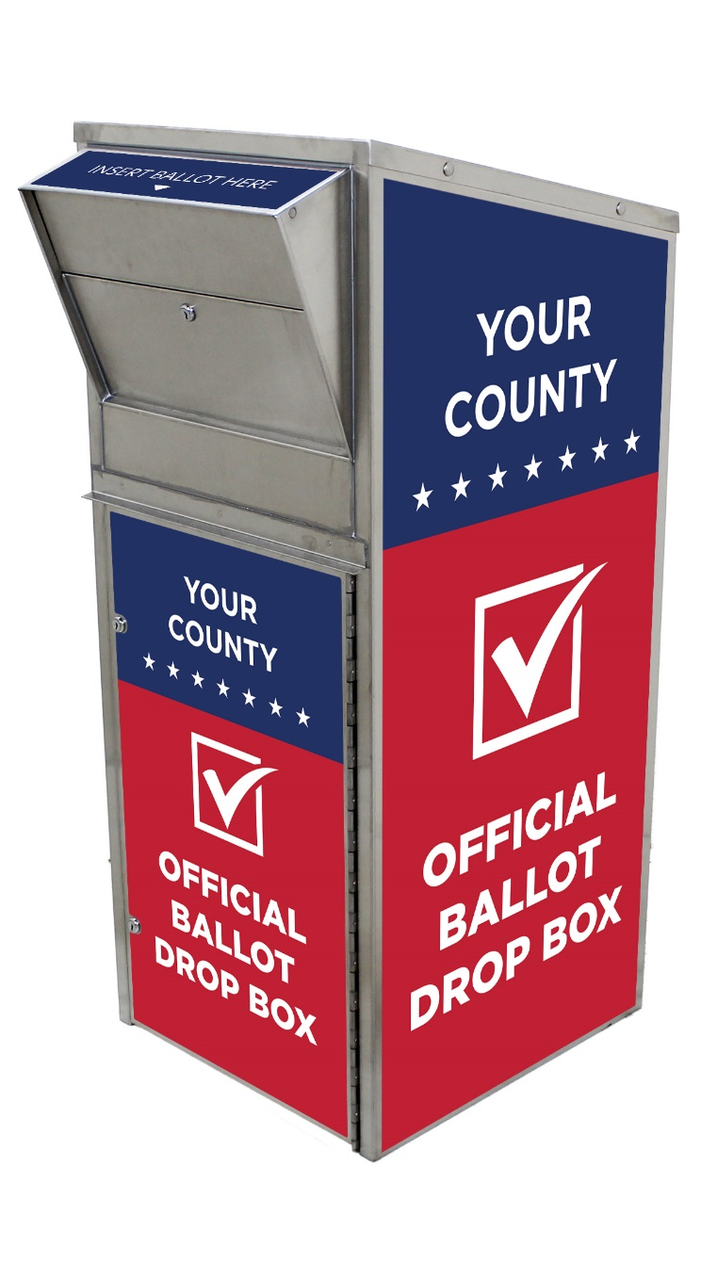

July 7, 2020 Primary Election

