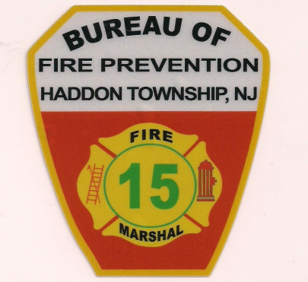

**Must be Attended by an Adult @ All Times During Use & Cannot be Left Unattended, Must be Extinguished Completely when completed & Not Being Utilized or in Use!!!**

**OUTDOOR FIREPLACE REQUIRMENTS**

***Approval/Use* - is contingent upon adherence to the following conditions:**

**1.** Must be in an approved container with an ember suppressing lid & on a solid level surface.

**2.** Shall only **burn clean, dry, untreated hard wood.**

**3.** Must be located **at least twenty five (25') feet from the nearest structure not on the same property & ten (10') feet away from all other structures/combustibles on the same property.**

**4.** Must **not create/cause a nuisance to neighbors**

**5.** **The use of flammable liquids or accelerants is prohibited**

**6.** **Burning of trash, trees, brush, grass, leaves, vegetation or any other material other than clean wood as described above is strictly prohibited**!!!

**7.** **Must have either a functional/operating garden hose and/or a Class-A fire extinguisher on site,** within proximity of the outdoor fire place during use.

**8.** I hereby acknowledge that I have read and fully understand the information provided, furthermore I understand that I agree to comply with the applicable requirements of **The NJ Uniform Fire Code & International Fire Code-NJ Edition, Township of Haddon &** **The Haddon Township, NJ Fire Marshal/Official** as directed, or **Fire Department Official** if a safety hazard is declared.

**Note:** it is the resident's/owner's responsibility to comply with any/all other applicable health, law enforcement, construction, electrical, plumbing, mechanical requirements if required.

*Failure to comply with the minimum requirements **may result in a** **penalty (1st Offense $50.00 / 2nd Offense $100.00) & suspend the use of the outdoor fire place,** until all requirements are satisfied.*

Thank you for your cooperation & understanding

**Haddon Township, NJ**

**Office of the Fire Marshal**

**Bureau of Fire Prevention**

10 Reeve Avenue

Haddon Township, NJ 08108

Office: 856.854.1176 Ext. #6269/6276

Fax: 856.854.8773