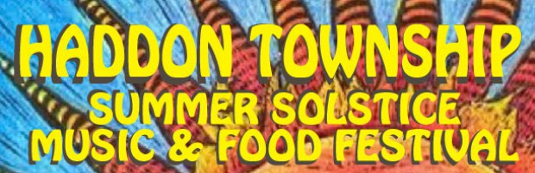
June 21st, 2018
4:00 pm to 10:00 pm
Booth Entry Form

The 2nd Annual Haddon Township Summer Solstice Music & Food Festival will be held on Haddon Ave. from 4:00 pm to 10:00 pm. We have a full schedule of free entertainment, a beer garden, games, crafts and more! Space is available to all area artists, craftsman, civic organizations and businesses. All general rules apply to the Summer Solstice.
Booth spaces are 10’ deep by 10’ wide, outdoors. Spaces are reserved upon receipt of
reservation fee on a first come/first served basis. Each 10 x 10 space is $30 for the day. Civic
Organizations/Non-Profits are free as long as the organization is not selling merchandise to raise funds. All exhibitors are expected to set up prior to the opening of the event and remain
open until the event is over at 10:00 pm. (No Exceptions)

Sales tax collection and payment to the State of New Jersey is the exhibitor’s responsibility.
Entry Deadline: June 11, 2018

Rates: $30 per 10’ x 10’ space per week. All checks should be made out to the Township of Haddon.
Contact Name:_________________________________________________________________________
Business Name:___________________________________________________________________
Address:______________________________________________________________________________
Phone:____________________________________Email:______________________________________

Detailed description of what you would sell at the event (include All products):
____________________________________________________________________________________________________________________________________________________________________________________________________________________________________________________________________________________________________________________________________________________

HOLD HARMLESS CONTRACT AGREEMENT
I assume responsibility for my own booth space and agree to relieve the Township of Haddon of liability for any damages beyond due care, including claims for loss, damage, or injury. I understand I am responsible for insurance on my merchandise and equipment at my own expense. I understand this is to include public liability. I agree to abide by the General Rules set forth and assume responsibility for installing my booth space.
Print Name____________________________________________________________________
Signature______________________________________________________________________
Date_______________________
Please mail completed application to:
Township of Haddon
135 Haddon Ave.
Haddon Township, NJ 08108

For more information contact:
Kate Burns at (856) 833-6267 or kburns@haddontwp.com

