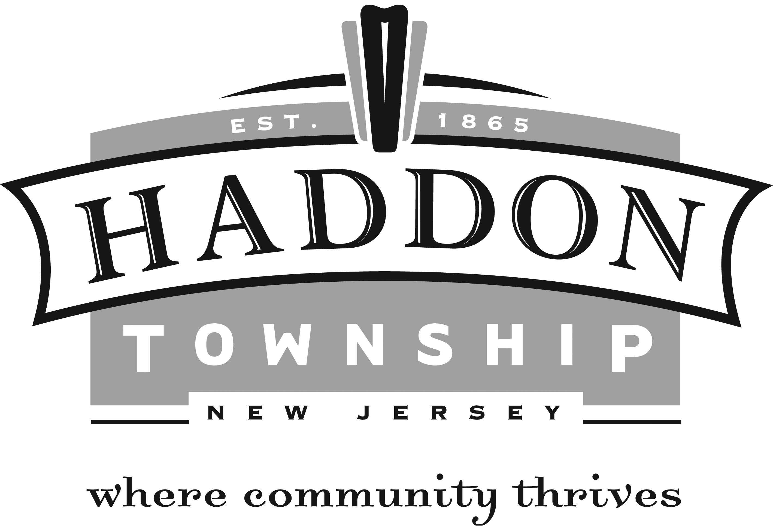

Housing Authority Board

NAME POSITION END OF TERM

JOSEPH IACOVINO EXECUTIVE DIRECTOR
ALMA ZWICK CHAIRPERSON 12/31/2014
MARY BERKO VICE-CHAIRPERSON 12/31/2017
FRANKLIN P JACKSON MEMBER 12/31/2017
ROSA TANZI MEMBER 12/31/2015
BRIAN SELTZER MEMBER 12/31/2016
LOUIS E CERNAVA MEMBER TENANT 12/31/2017

The Housing Authority was established in conjunction with the provisions of the Local Housing
Authorities Law of the State of New Jersey (N.J.S.A 55:A-1 et seq.). It oversees the operation and management of the Rohrer Towers I Senior Housing Complex.

The Housing Authority holds meetings on the third Wednesday of every month at 7:00 P.M. in its office at 25 Wynnewood Avenue.

More information on the Housing Authority can be found directly from the Housing Authority at (856) 854-3700.

