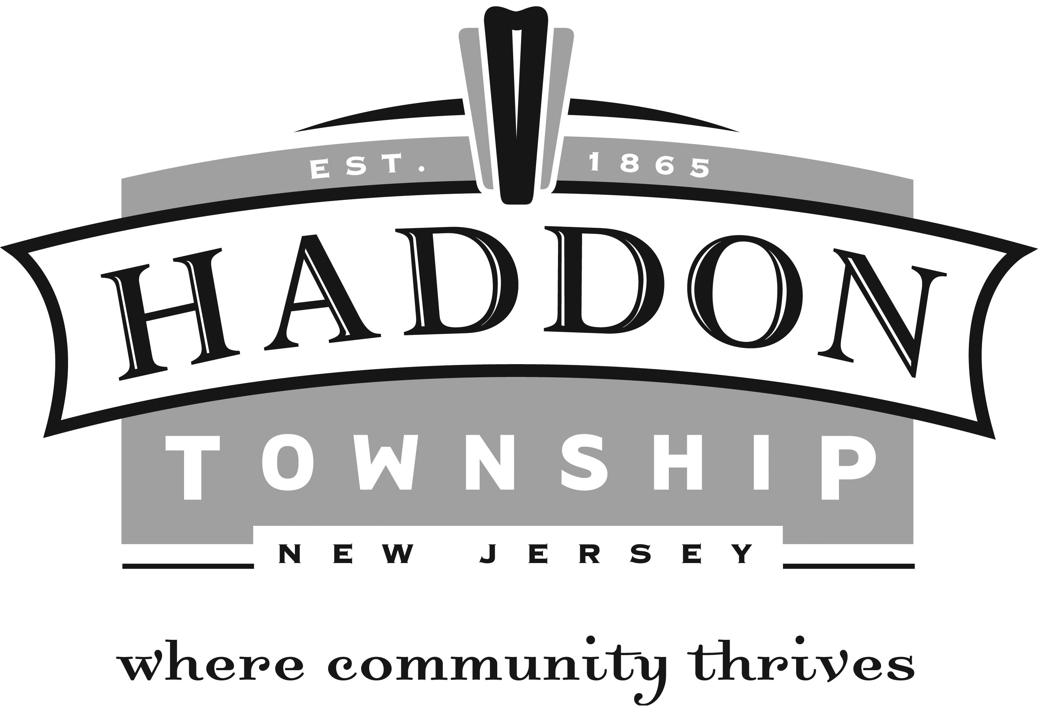

Municipal Court Office

The Municipal Court Office handles fine payments and other court issues. Individuals can make payments on their violations (tickets) in person, by mail, or online at www.njmcdirect.com. (Please note that you will need the court code, ticket number, and tag number for web payments. Disorderly fines are not payable online at this time.).

Contact Information:

Robert Gleaner, Esq. Judge
Mary Soldano, CMCA Court Administrator Ext. 4140 mtwisler@haddontwp.com
Sandra Logan Dep. Court Administrator, Ext. 4116 smielcarz@haddontwp.com
Laura Donohue Recording Clerk Ext. 4139
Steven Petersen, Esq. Municipal Prosecutor
Charlene Cathcart, Esq. Public Defender

Court Sessions: Municipal Court sessions are held on the second, fourth, and fifth Wednesday at 4:00 PM as well as the third Wednesday at 8:30 AM. In addition to Municipal Court, the Office also oversees the Community Dispute Resolution Committee. Haddon Township Community Dispute Resolution Committee (CDRC) utilizes volunteers, trained as mediators to settle disputes. The CDRC Program was created to achieve several goals; early intervention in less serious community and interpersonal tensions, remove the necessity of a court record for minor personal disputes and to relieve congestion in the court.

Paying Tickets by Mail
You can also pay by mail to the address above. Please include the ticket or a copy with your check or money order. Do not send cash. Please include a self-stamped address envelope if you would like a receipt. If payment is received after the appearance date, you may be assessed additional penalties.

Paying Tickets in Person
You may pay your ticket in person at the Violations Bureau on the second floor of the Municipal Building at 135 Haddon Avenue. Please bring your ticket with a check or money order between the hours of 8:30 a.m. to 4:00 p.m. Please include a copy of your ticket or your case number with your payment.

Paying Tickets Online
The State of New Jersey and the Borough have provided a new service to our customers. Payable moving tickets and parking tickets can be paid on the internet using a VISA and MASTERCARD. Directions for payment, frequently asked questions, information on the Point System and more can be found on http://www.judiciary.state.nj.us. To pay tickets on line you will need the following information:

Court Code – 0416
Ticket number including the letter prefix
License plate number
Credit Card – VISA, MASTERCARD, or DISCOVER

Contesting Tickets
If you plan to enter a not guilty plea to a traffic summons, you must notify the Court Administrator at least 5 days prior to your scheduled court date. If you fail to do so, it may be necessary for you to make two court appearances. Only those tickets with a checked court appearance date will be listed for court. If you have a summons that does not require a court appearance, but would like to appear, please follow the procedure above.

Failure to Appear
If you fail to appear in response to a summons, or to pay the penalty, additional charges may result. A warrant for your arrest may be issued, and your driving privileges in New Jersey may be suspended. If you have been issued a parking ticket, and fail to appear or pay the penalty, the owner of the vehicle may be subject to the same consequences listed above. If you have any questions for the Municipal Court, please feel free to contact our office during regular business hours.

