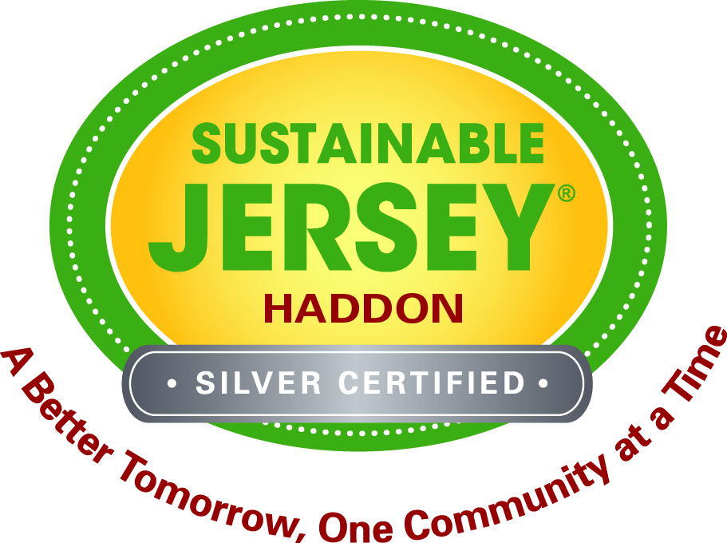

Rain Barrel Workshop

Make your own Rain Barrel
Saturday, March 21, 2015
10:00 am – 12 pm

- Haddon Township Environmental and Historical Center,
143 E. Ormond Avenue, Haddon Township, 08107.
- Registration is required, $45.00 per person.
- Learn how to make and install your own rain barrel, PowerPoint Presentation
prior to hands instructions to Build your own Rain Barrel
- Maximum number participants is 20 (limit of 20 barrels)
- Sponsored by Rutgers Cooperative Extension and
Sustainable Haddon Township
- Payment required with registration, one barrel per paid registration
- Please be sure you can get your barrel home after the workshop
- Minimum of 10 participants required to schedule this event

Contact Mike Haberland at Haberland@njaes.rutgers.edu or
856-216-7130 ext. 3, BEFORE sending payment to ensure that space is available.

Name__________________________________#Attending___________
Address___________________________________________
Email_______________________Phone_________________

Send completed registration form and
check payable to “CCBA” and send to:
Rutgers Cooperative Extension of Camden County;
1301 Park Blvd, Cherry Hill, NJ 08002
ATTN: Mike Haberland

(PayPal payment is also available, $1.60 add’l charge)

