The Haddon Township Block Party D.A.R.E Car Show
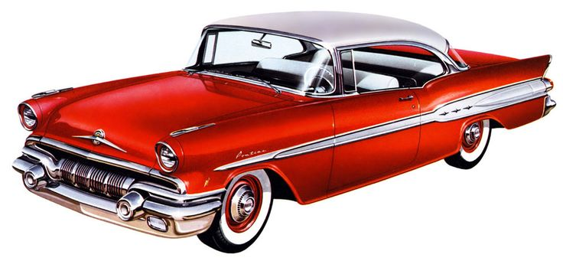
(Domestic and Import Cars, Trucks, Motorcycles Welcomed)
Saturday, September 23rd, 2017
Show Location: Crystal Lake & W. Park Ave 08108 Set-up/Registration 9:00am / Show hours 12:00-6:00pm (Rain date September 24th) Displays, Exhibits, Exciting new Arts and Crafts Vendors, DJ, Food Court, Beer Garden, Live Bands, Amusements and Rides Galore!!
Fun for the whole family!!!!
Proceeds of your $20.00 donation will directly benefit the Haddon Township Police Department DARE program, which is dedicated to educating our children about the dangers of drug and alcohol.
Name__________________________________________Address________________________________________
City________________________________________________ State________ Zip___________________________
E-mail___________________________________ Phone (for cancel of show) _______________________________
Vehicle Make_______________________ Year____________ Model______________ Shirt size__________
Please make your $20.00 check payable to the Township of Haddon and mail to Township of Haddon Municipal Building. (135 Haddon Ave. Haddon Twp. NJ 08108. Attention Car show.)
If you have any questions or if additional registration forms are needed for the car show, please contact 856 854-1176 ex. 6267 or kburns@haddontwp.com
Please visit www.haddontwp.com the morning of the show if inclement weather is expected. Thank you in advance for your support.

